1. 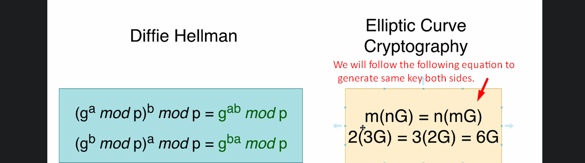
2. 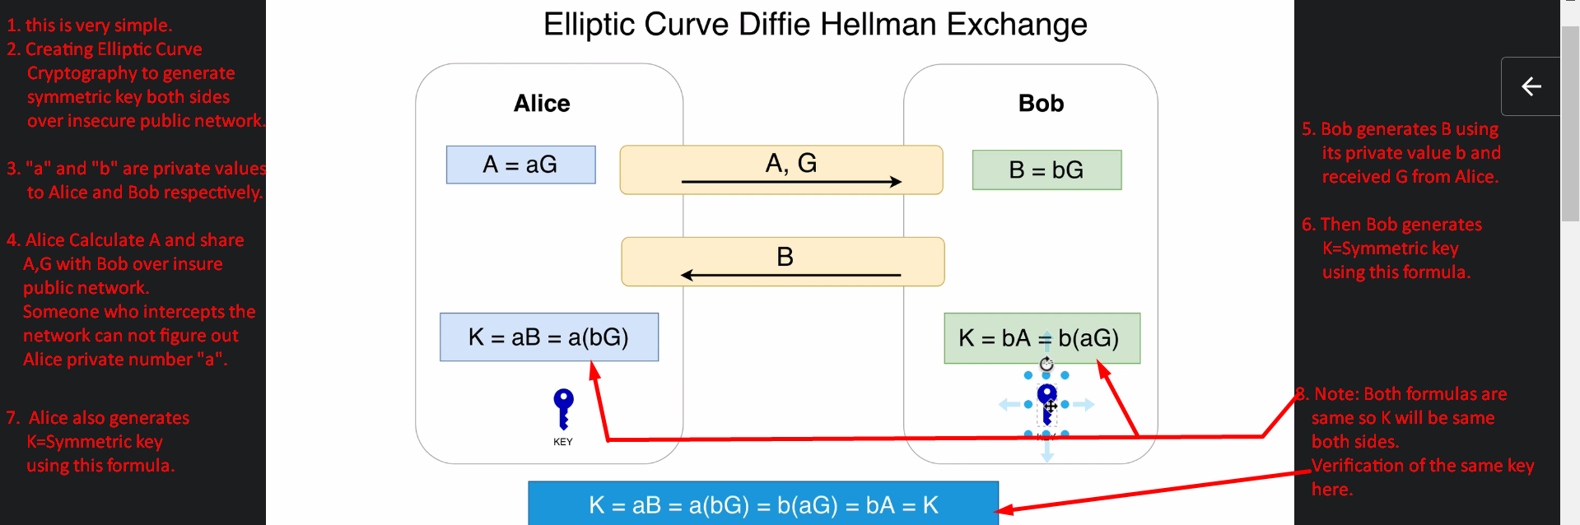
3. In next lecture, let’s examine and analyse what we discussed here with Wireshark.